Following are the step need to configure docker compose start up Jenkins process

Step 1: Create a Jenkins job and provide the following details in window command exe

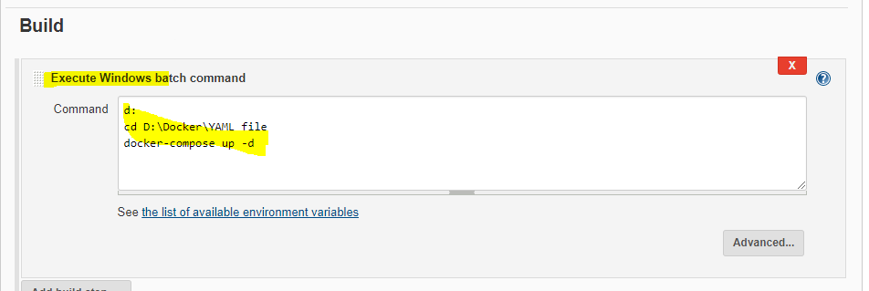

Note: docker-compiose.yml file should exist at the location defined in above window exe batch command.

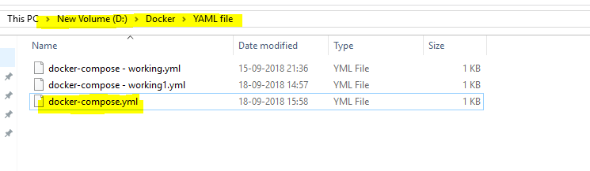

Contents of docker-compose.yml file should be as follow:

seleniumhub:

image: selenium/hub

ports:

- 4444:4444

firefoxnode:

image: selenium/node-firefox-debug

ports:

- 5900

links:

- seleniumhub:hub

chromenode:

image: selenium/node-chrome-debug:3.5

ports:

- 5900

links:

- seleniumhub:hub

Step: Build the job and should be run successfully.

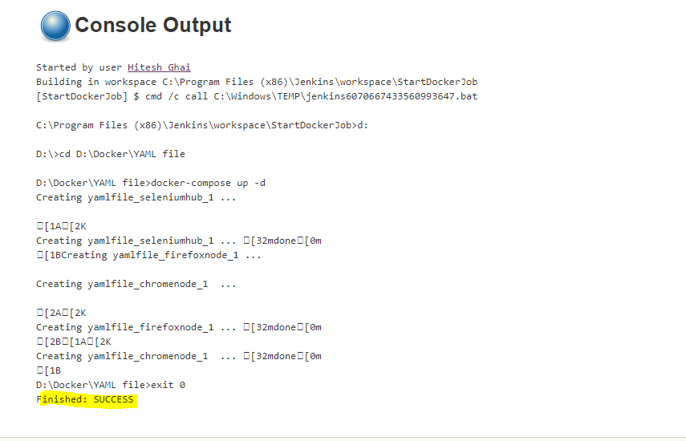

Now, check whether container/images created successfully or not

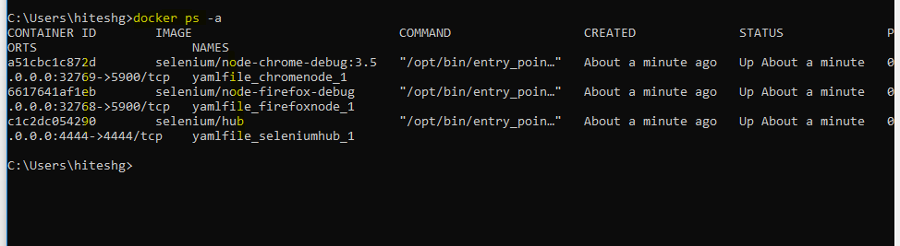

Open VNC and check the images

